

|  |
| --- |
| Creating Web Report  2022 |
|  |
| April 11  Nguyen Nam Tung  Student ID: 103181157  Course: COS10026 |

# Table of content

1. Table of content 2

2. Introduction 2

2.1. Website introduction 2

2.2. Report objective 2

3. Website content 2

3.1. Index page 3

3.2. Topic page 3

3.3. Quiz page 4

3.4. Enhancement page 4

4. Website style 4

5. Key features 6

6. Conclusion 6

# Introduction

## Website introduction

Our personal website, Coffee Script, contains information about the programming language’s author, key features, and some comparisons with the other popular programing language. Additionally, there is a quiz page for users to review their progress, to help them understand more about this very interesting programming language. There is also an enhancements page that contains all the enhancements made to the project.

## Report objective

This report provides an in-depth examination of the process of creating a static website, specifically how HTML and CSS were implied. Besides that, a list of technical issues encountered during the website's development will be provided.

# Website content

Site map of the website

## Index page

This page is used to provide the users with some fundamental ideas and concepts behind Coffee Script – one of the least popular programming languages. There is a navigation bar at the top of the page that allows the users to access other pages such as the topic page. The index page's body is divided into numerous sections using the <section> and <div> tags. Additionally, there is a figure element containing an image of the creator of Coffee Script and its caption. A footer with the names that link to the email of the team members appears at the end of the introduction page. The footer and navigation bar are also present on the website's other pages.

## Topic page

This page contains some of the most critical information about Coffee Script, including its creator, its growth and decline,... The body of the topic page contains numerous sections and divisions, as well as an aside element containing the Coffee Script logo. Additionally, a table that compares different programming languages appear in one division of the topic page. Ordered and unordered lists are also being used for the content and the reference of the web page.

## Quiz page

This page contains a list of questions related to the topic page. The quiz is a form containing five <fieldset> tags, each of which corresponds to a different question. At the bottom of the page, there is a button for submitting the form's responses.

## Enhancement page

This page is a list comprising all the enhancements made to this website. They are in one <section> tag.

# Website style

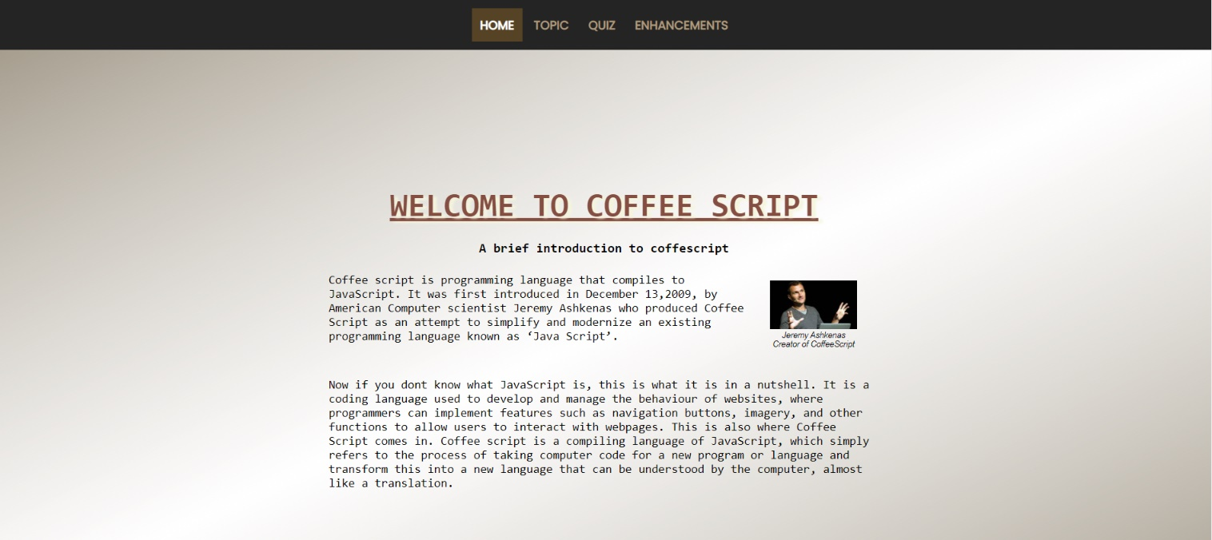

The main theme color of the website’s index page is white and brown, and this is also applied to the other pages such as the topic page, the quiz page, and the enhancement page. All the headings, paragraphs, and sections of the webpage are centered to make it easier for the users to read.



The navigation bar appears on every page of the website. It allows users to have access to the other web pages. When the mouse cursor is moved to one of the navigation links, the text color becomes white. Additionally, when the navigation bar is on a page, for instance, the home page, the element corresponding to the home page will have a brown box as a border and the text also become white. Also, text-decoration has been set to none so after visiting, it will look much cleaner



Additionally, the footer is an element that appears on each page of the website. It includes links to each team member's student email address. When the mouse is moved onto one of the names, the text changes color from grey to white.

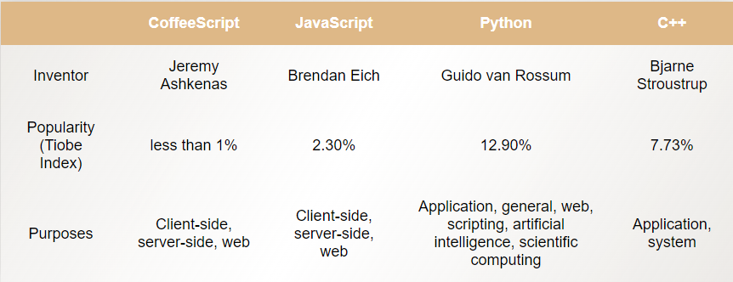

The table on the topic page is also colored to match the Coffee Script website's theme. The color of the table heading has been changed to brown, while the background color

of the table data has been changed to white. Additionally, all text in the table is centered.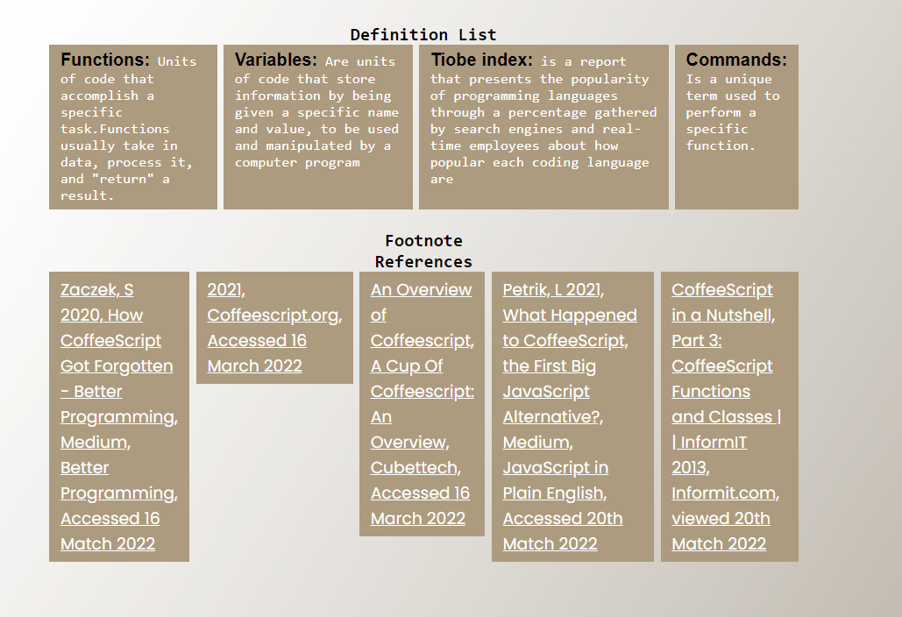

All ordered and unordered lists on the website are horizontal with a brown background color. The text's color has been changed to white to match the background.

# Key features

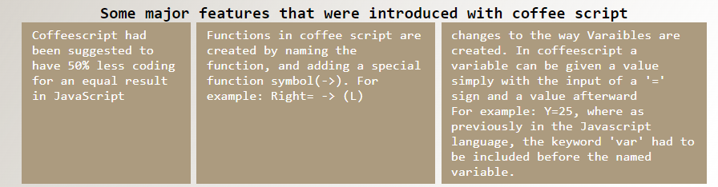

All the list elements appear in a rectangular box.



The Coffee Script website has been added an icon to help the users easily identify the website.

# Conclusion

In general, this report has discussed the HTML and CSS utilized for the Coffee Script web page and how they have been applied to create a static website. However, the website still has some issues. For instance, the font size of the content may be difficult to read for some users. Furthermore, some parts of the website such as the headings and the CSS for the navigation bar are not consistent with all the web pages. Last but not least, the Coffee Script website lacks innovative features such as rotating objects or animated transitions from one page to the others.